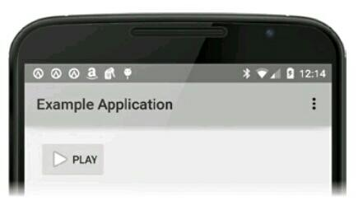

**Button**

<Button...

android:drawableLeft="@android:drawable/ic_media_play"

android:background="@drawable/button_custom"

android:text="Play"

android:onClick="button_onClick />

ImageButton

<ImageButton

android:src="@android:drawable/ic_media_play" />

Bắt sự kiện Click:

.setOnClickListener(new View.OnClickListener() {

@Override

public void onClick(View v) {

// Button clicked

}

});